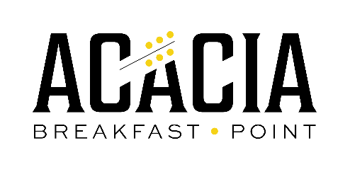

**RESPONSIBILITIES OF THE ACACIA STRATA COMMITTEE**

* All Committee members are expected to attend Strata Committees 4 times a year.
* To enable handling of ongoing issues between scheduled meetings, information is often circulated by email and if required, decisions are made and communicated by email. These decisions are then ratified at the next formal meeting of the Strata Committee. This requires that ALL Committee members are involved in the communication process.
* All Committee members are expected to take an active interest in the management of the Strata.
* The Committee meets on an informal basis between scheduled meetings to discuss and manage issues if this is appropriate. Any decisions made are then ratified at the next formal meeting of the Strata Committee.
* All Committee members are expected to be in email contact and to respond promptly to email re issues affecting Acacia, endorsing issues, etc.
* The Treasurer is expected to advise the Committee members of approval of ongoing expenditure.
* All Committee members are to communicate resident’s issues/building maintenance with each other and any further problems/needs are to be addressed by the Chairperson/Strata Manager.

**Committee Members/Residents are also invited to be involved in the following areas:**

* Recommending Maintenance and Defect Works Programs.
* Consulting with the Gardening Committee to amend the building Architectural & Landscape standards.